Annual report
April 2012 to march 2013

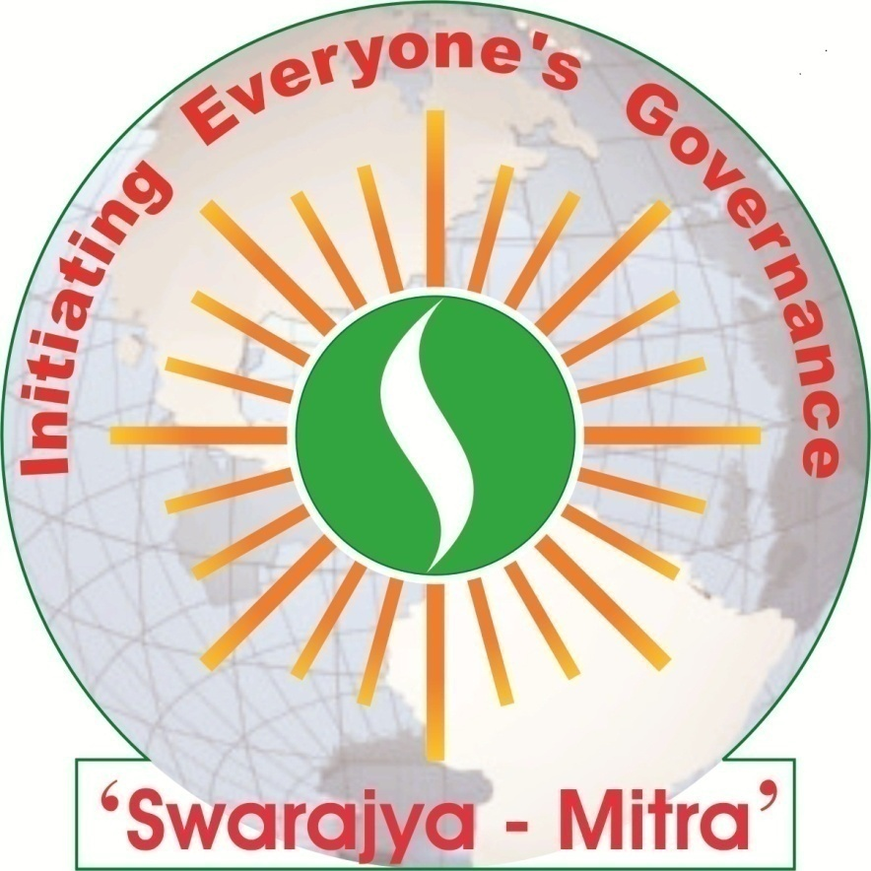

‘Swarajya – Mitra’ Samajik Sanstha
(Initiating Everyone’s Governance …)
Registered Society and Public Trust
Website: http://www.freewebs.com/swarajyamitra
Registered Office:
At Post Anjangaon-Bari,
Via Badnera; Tal. Dist. Amravati;
(Maharashtra State), India. Pin – 444701
Telephone No.: 0721-2385204, 09423102983
Email: swarajya.mitra@rediffmail.com
Vision
Establishing Swarajya that is
Self-governed human community having inner-strength and a sense of responsibility in which, every individual have power and a realization of governance
Life-Time Work
Evolving people’s power based on compassion, love and mutual cooperation
Mission
Promoting community councils making decisions on consensus only to ascertain reverence for life in the village or hamlet

Development Initiatives Planned
And Area of Operation

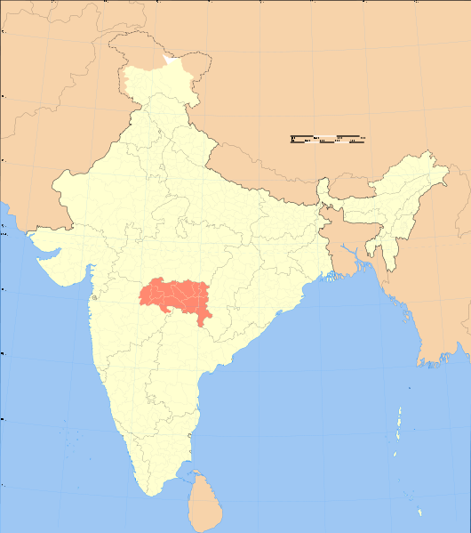

Indirect Outreach Area – Vidarbha Region
Intensive Work Area in Amravati District

Population Coverage under Direct Intervention
Total population of 12,973 (male 6,740 and female 6,298)
in 15 villages in Chandur (Railway) block of Amravati District
GramPanchyat | Village | House Hold | Population
 |  |  | Male | Female | Total
Wai (Both) | Wai (Both) | 199 | 438 | 397 | 835
Kirjawala | Kirjawala | 132 | 276 | 264 | 540
Bori | Bori | 320 | 712 | 671 | 1383
Dhotra | Mogara | 74 | 148 | 141 | 289
Dhotra | Dhotra | 113 | 230 | 215 | 445
Jawla | Jawla | 259 | 574 | 483 | 1057
Tonglabad | Tonglabad | 171 | 394 | 357 | 751
Dhanora (Moghal) | Dhanora (Moghal) | 253 | 578 | 523 | 1101
Tonglabad | Ekpada | 59 | 142 | 130 | 272
Kohla (Khanapur) | Kodri (Harak) | 43 | 80 | 79 | 159
Kharbi | Kharbi | 242 | 520 | 485 | 1005
Rajura | Rajura | 596 | 1355 | 1311 | 2666
Kavatha | Kavatha (Kadu) | 402 | 937 | 820 | 1757
Kavatha | Budali | 25 | 65 | 129 | 129
Savangi (Sangam) | Savangi (Sangam) | 126 | 291 | 293 | 584
12 | 15 | 3,014 | 6,740 | 6,298 | 12,973
Focus Group for Direct Intervention
Right to Education Initiatives
Villages | 6 to 14 Years Age-Group Children |  |  | Out of School Children in 6 to 14 Years Age-Group |  |  | Children with Disabilities 0 to 18 Years Age-Group
 | Boys | Girls | Total | Boys | Girls | Total | Boys | Girls | Total
15 | 871 | 748 | 1,619 | 33 | 25 | 58 | 18 | 18 | 36
Population Coverage under Indirect Intervention
25 partner NGOs of ‘Shikshan Hakka Abhiyan’ working with total population of 2,85,440 (male 1,46,699 and female 1,38,741) in 283 villages in 19 blocks of 11 districts in Vidarbha region.
Empowering Deprived People through Organization
People’s Organization | No. of Organization Formed | Members
 |  | Male | Female | Total
Children Group | 12 | 102 | 112 | 214
Adolescent Girl’s Group | 15 | - | 224 | 224
Youth Group | 15 | 239 | - | 239
Child Rights Protection Committee | 15 | 134 | 146 | 280
Network Participation
- ‘Shikshan Hakka Abhiyan’ (Right to Education Campaign), Maharashtra
- Child Rights Alliance, Central India
- Kisan-Mitra (Friends to Farmers), Central India
- Disability Inclusive Development Forum, Madhya Pradesh
Initiative Based Programs

Promoting Life-Oriented Education, through;
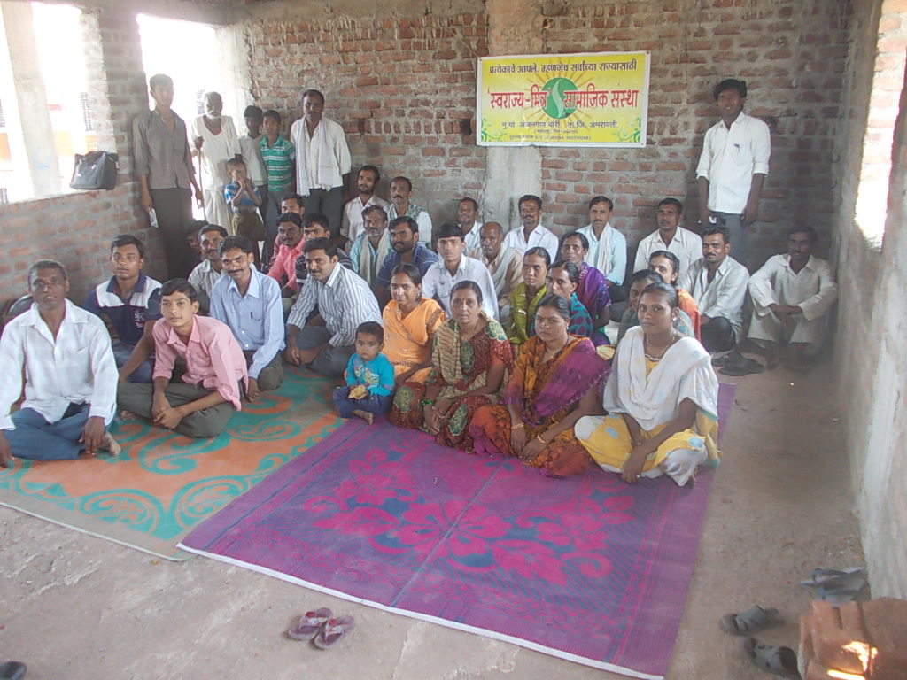
- Right to Education Thematic Support to Campaign Partners
- Training for Panchayat Raj Institute (PRI) Members
- Training of Village Youths and Women Groups
- Child Labourers and Girl’s Education Status Study
- Establishing Child Tracking MIS and School Monitoring
- Social Audit on Implementation of Right to Education
- Coordination with Government Officials and NGOs on Right to Education
- Training for School Management Committee (SMC) Members

Promoting Sustainable Secured Livelihood and Prosperity, through;
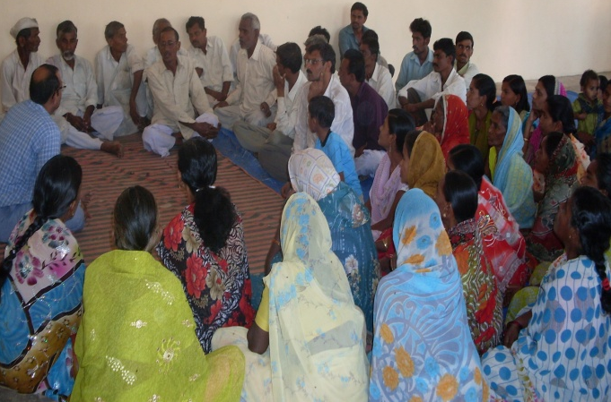
- Study article presentation on farmer’s in foreign direct investment (FDI) multi-brand retail
- Environmental education programme in villages by film show ‘Thali Me Jahar’ (documentary film on genetically modified food) and ‘Mere Desh ki Dharati’ (documentary film on ill-effects of green revolution and need of organic farming)
- Initiating process of formation of farmer’s groups

Promoting Gender Equity and Power to Deprived People, through;
- Advocacy for dignity and rights of girl students with disability by presenting human interest story of Rashmi Kakade, age-inappropriate girl student with 100% disability in the public hearing

Promoting Treatment and Preventive Health Education, through;
- Representation in Right to Sanitation State Level Campaign organised by FANSA

Highlights on Initiatives
- Status Study of Persons with Disabilities, 2011-12; data processing and analysis is completed.
- Through this study ‘Swarajya-Mitra’ has introduced ‘Disability Development/Deprivation Index’. A process of standardizing a new tool in monitoring and evaluation for grounding of rights and rehabilitation of persons with disabilities is initiated.
- Based on the 36 indicators, the ‘Disability Deprivation Index’ of the area is very high as 68.46, needing urgent intervention for disabled inclusive overall development of the society.

Kirjawala, Wai (Both), Dhotra, Mogara, and Jawala; these 5 villages are advancing towards organised as the community councils for initiating everyone’s governance.

- Wai (Both) GramSabha has recommended scholarship for Prajjwal and Khushi, siblings with multiple disabilities.
- Child Tracking MIS is established for 277 households in the 5 villages.
- Children’s Group, Adolescent Girl’s Group, Youth Group, and Child Rights Protection Committees are active in the 5 villages.
- School Management Committees (SMC) is regularly meeting in the relevant 5 primary schools. The 5 SMCs have performed social audit on right to education of the children, through which a number of irregularities were pointed out. The SMCs are pursuing it with authorities for better implementation of right to education of children.

Contacted 1266 farmer families for promoting organic farming and agricultural biodiversity in 15 villages

We are Thankful
Programme and Funding Partners 2012-13
Sr. No. | Name of the Programme | Funding Agency | Amount in INR
1. | Right to Education Initiatives | Apeksha Homoeo Society, Mozari | 1,36,000.00
2. | Strengthening the Implementation of Right to Education in Maharashtra by Enabling Greater Convergence among Different Stakeholders Working on Child Rights Issues | Apeksha Homoeo Society, Mozari | (indirect funding for programme implementation in the 15 villages)
We are Thankful
Individual Donors 2012-13
Sr. No. | Name of the Donor | Purpose | Amount in INR
1. | Mr. Narendra Bais, AnjangaonBari, Amravati | Charity | 20,000.00
We are Thankful
Professionals and Service Providers
Main Bankers: State Bank of India, (Branch Code 04884), Nandanwan, Railway Station Square, Badnera, Dist. Amravati. (M.S.) Pin – 444701.
Statutory Auditors: M/s. Agrawal Sharma & Associates, Chartered Accountants, 203, Tank Plaza, Ambadevi Road, Amravati. Pin – 444601. Phone No. (0721) 2562512, 3204108
We are Thankful
Volunteers with ‘Swarajya-Mitra’
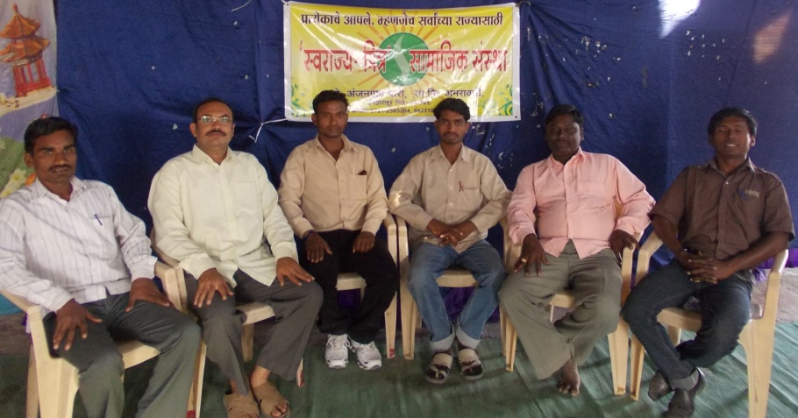
Left to Right: Satish, Rahul, Sandip, Sushil, Rahul and Chandrashekhar
COMPLIANCE REPORT
- Registration:
- Society Registration Act, 1860: MAH/20/08 (Amravati) Dt.11/01/2008;
- Bombay Public Trust Act, 1950: F-15445 (Amravati) Dt. 21/02/2008;
- Income Tax Act, 1961 (12A): F.No.CIT-III/12AA/2008-09; Dt. 23/01/2009;
- Income Tax Act, 1961 (Permanent Account Number – PAN): AAHTS4925M;
- Income Tax Act, 1961 (Tax Account Number – TAN): NGPS11673E;
- Maharashtra State Professional Tax Act, 1975 (P.T.R.C.): 27335248970P.
- Planning Commission of India, Unique ID: MH/2013/0063593
- Clarity and Commitment about Mission & Approach:
- Well defined and articulated mission & approach in memorandum of association, policy documents, and various internal reports of the organization
- Translation of mission & approach in programs and activities is well ensured
- Special efforts are taken through participatory processes towards developing clarity and acceptance of the mission & approach among staff members, beneficiaries, and partner community
- Governance and Programmatic Operations:
Executive Committee Members and their Position on the Committee, and
General Body of the Organization - Members of the organization
(As on 31st March 2013)
Sr. No. | Name | Position | Age | Gender | Place | Occupation / Area of Competency
1. | Mohan Hirabai Hiralal | President | 62 | Male | Chandrapur | Senior Consultant; environment and human relationship, village self-governance
2. | Shubada Shridhar Deshmukh | Vice-President | 54 | Female | Kurkheda | Social Worker, women empowerment
3. | Rahul Narendra Bais | Secretary | 41 | Male | Anjangaon Bari | NGO Support Service Provider; village self-governance
4. | Devaji Navalu Tofa | Member | 56 | Male | Mendha (Lekha) | Farmer; village self-governance
5. | Karuna Vasant Futane | Member | 54 | Female | Rawala | Farmer; women empowerment and agro-entrepreneurship
6. | Chitra Parag Cholkar | Member | 56 | Female | Nagpur | Professor, Dept. Of Statistics, Nagpur University; Gandhian Thoughts
7. | Avinash Vinayakrao Shirke | Member | 46 | Male | Yavatmal | Principal, College of Social Work, Amravati University; Watershed and Agro-Development
- According to ‘Swarajya-Mitra’ Rules and Regulations, the executive committee serves as Board of Trust.
- The board rotation practice exists and is practiced.
- There is no remuneration/reimbursement to Executive Committee Members.
- The ‘Swarajya-Mitra’ Executive Committee met 2 times in financial year 2012-13.
- The Executive Committee has approved projects, programs, budget, annual reports, and financial audit reports.
- The Executive Committee has ensured the organizations compliances with laws and regulations.
- The ‘Swarajya-Mitra’ General Body met once in financial year 2012-13.
- The General Body has approved decisions of the Executive Committee regarding projects, programs, budget, annual reports, and financial audit reports.
- The General Body has ensured the organization’s compliances with laws and regulations.
Activity targets and systems for ongoing monitoring and review
- Apart from well established project based activity targets and systems for ongoing monitoring and review, ‘Swarajya-Mitra’ ensures it through monthly meeting and yearly review with all staff members.
- ‘Swarajya-Mitra’ also have promoted external review.
Formation of Advisory Committee
- ‘Swarajya-Mitra’ is in the process of formation of the advisory committee.
Policy for purchase, storing and issuing
- Well defined policy for purchase, storing and issuing is in place.
- Purchase of items more than Rs.10,000 are sanctioned only by organization level procurement committee after seeking expert advice on the available quotations.
- Purchase of items less than Rs.10,000 are sanctioned by the Project Director or equivalent positioned officer, duly verified by the Secretary of the organization.
Maintenance of Asset Books
- Asset book for is maintained up to date and are duly audited every year.
- Human Resource:
Details of staff (as on 31st March 2012)
Sex | Paid Full-Time | Paid Part-Time | Paid Consultants | Unpaid Volunteers
Male | 01 | 00 | 00 | 04
Female | 00 | 00 | 00 | 01
Total | 01 | 00 | 00 | 05
Salaries and benefits of the Staff and the NGO head
- ‘Swarajya-Mitra’ mandatorily pays salary directly to the bank account of the staff.
- Formal appointment orders and booklet on ‘Swarajya-Mitra’ norms and rules & regulations are issued to all staff.
- No salary or benefit is paid to the NGO Head; however, salary and/or benefit eligible for the project/programme staff are paid accordingly.
Eligible and additional benefits for staff:
- Employee’s Provident Fund – Not Applied
- Pension & Gratuity scheme - Not Applied
- Leaves – Average No. of leaves taken by the staff in the year is 79 days per person
- MSRTC Accident Insurance Policy and Annual Travel Concession - No. of Staff Members 01
- Janata Accident Insurance Policy - Not Applied
- Medical Insurance Policy - Not Applied
- Exposure Tour - No. of Staff Members 01 visited MV Foundation, Andhra Pradesh
- During the year 01 persons joined the organization as the staff member and none have left
- The organization has taken conscious efforts to build family spirit and informal work culture. Formal staff family get-together was not organized this year; but informal get-together occurred.
- Monthly meetings of the overall staff including volunteers were organized throughout the year.
- Annual Review and Planning meeting of the overall staff including volunteers was organized in April first week.
- ‘Swarajya-Mitra’ encourages and makes available opportunities to all staff members for capacity building and professional development through relevant trainings, workshops and conferences at regional, national and international level.
- Accountability and Transparency:
- ‘Swarajya-Mitra’ publishes its annual report every year especially for stakeholders including well-wishers and funding partners. From this annual report 2012-13, ‘Swarajya-Mitra’ has started to share the PDF version on website. Audited annual accounts are also enclosed in the annual report.
- Project wise yearly budget exercise and monthly financial review is worked out in the staff meetings, whereas at organizational level executive committee exercised it in the executive committee meetings.
- ‘Swarajya-Mitra’ has well laid out accounts & administration manual in line with standard accounting practices and is ensuring practicing it systematically.
- Emphasis on receipts and bills for every financial transaction including in-kind donations is ensured.
- Accounts monitoring with accounts & finance department is held every month, while closing balance and cash scroll is verified every day.
- ‘Swarajya-Mitra’ accounts are audited by professional experts, and are published every year.
- ‘Swarajya-Mitra’ is planning in the direction to share accounts & expenditure with local community through get-together of local well-wishers.
- Till now, ‘Swarajya-Mitra’ is not having evaluation and review by external agencies. The evaluation and reviews are planned along with well-documented reports to make available.
- ‘Swarajya-Mitra’ is taking conscious efforts in implementing and having strict adherence for norms of statutory requirements like donations/contributions, income tax, professional tax, charity commissioner, etc. Acknowledgement of the relevant letters, challan and reports are duly filed.
- Total Cost of International Travels by All Personnel (Including Volunteers): There was no international or domestic travel by any member of organization or staff member of ‘Swarajya-Mitra’.

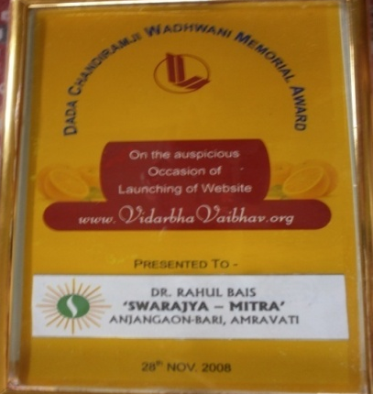
AWARDS

Dada Chandiramji Wadhwani Memorial Award 2008
for social initiatives
by ‘Vidarbha Vaibhav’, Nagpur

AUDITOR’S REPORT
BALANCE SHEET 2012-13
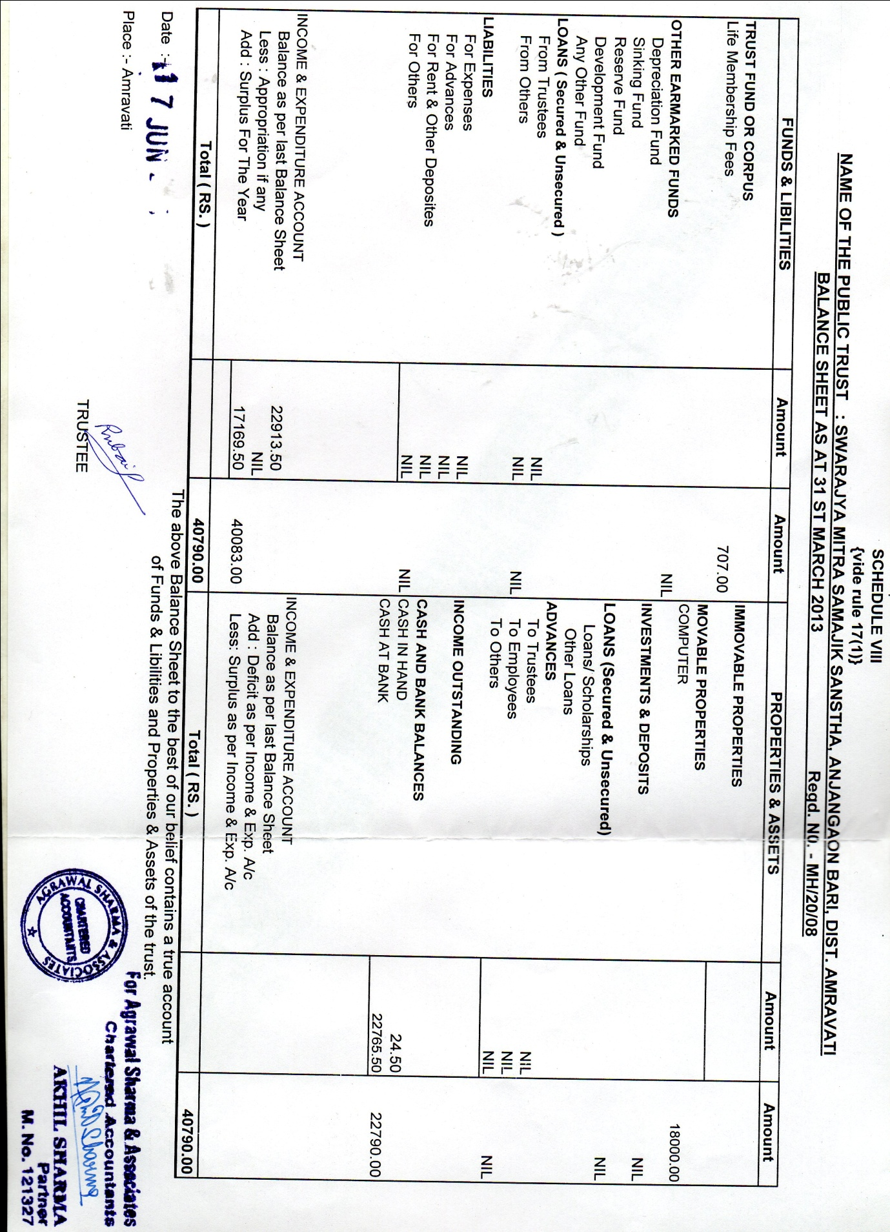
Income & Expenditure Account 2012-13
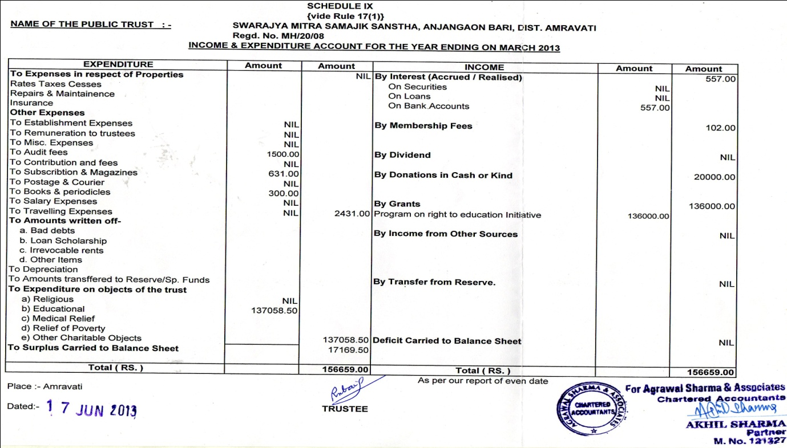
Receipt & Payment Account 2012-13
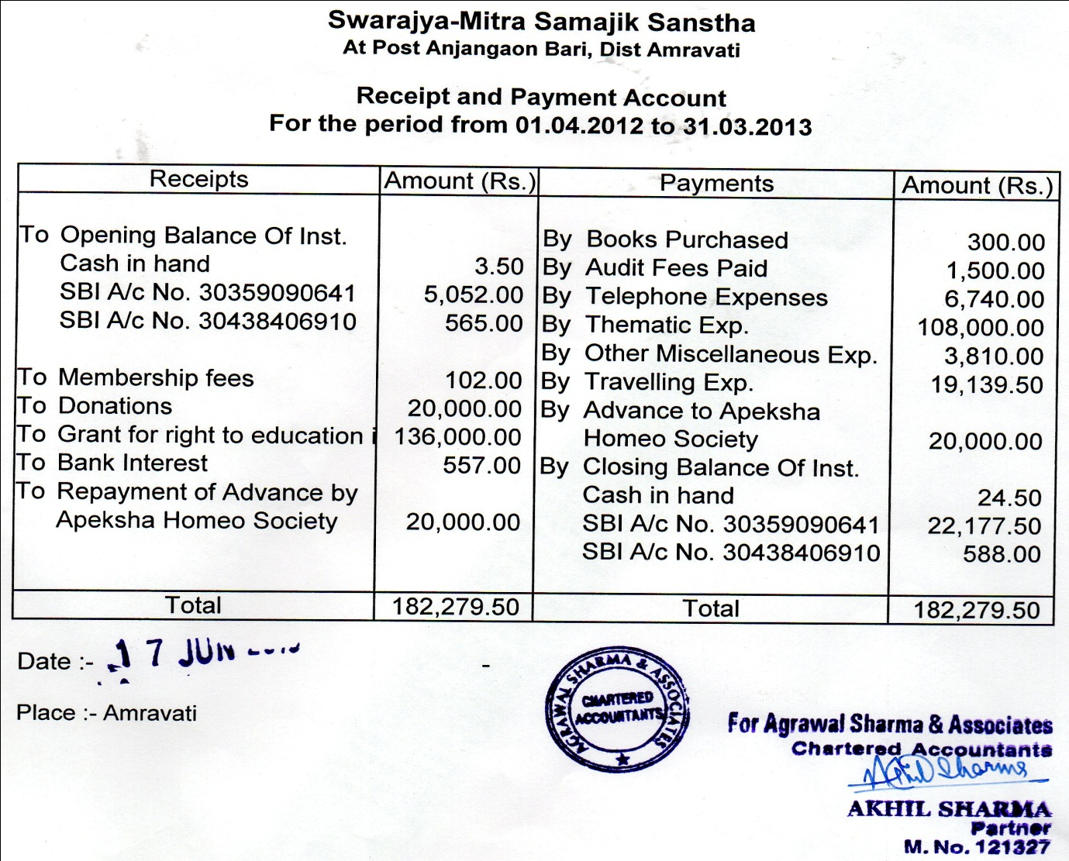

‘We All’
for Everyone’s Governance
You can also participate in the concept and strategy for Swarajya, through the following suggested ways –
- Illustrating, discoursing and disseminating ‘Swarajya – Everyone’s Governance’ in modern context
- Volunteering in the constructive innovations for everyone’s governance
- Fund raising support to ‘Swarajya-Mitra’
- Donations to ‘Swarajya-Mitra’ in kind and/or in cash for administrative expenses
- Donations and financial assistance to ‘Swarajya-Mitra’ for program expenses
- Project based financial assistance to ‘Swarajya-Mitra’

‘Swarajya – Mitra’ Samajik Sanstha
(Initiating Everyone’s Governance …)

